 

Analysis of Amazon Cell Phone Reviews

**U15CS705R - COMPREHENSION AND TECHNICAL REPORT**

**Activity 3**

*submitted by*

**ANANTHA PRIYA K (1517102011) **

**APSARA S (1517102014) **

**ARSHIA THASNIM S (1517102016) **

**VII Semester**

**COMPUTER SCIENCE AND ENGINEERING**

SONA COLLEGE OF TECHNOLOGY

*(An Autonomous Institution)*

**ANNA UNIVERSITY: CHENNAI 600 025**

December 2020

**ANNA UNIVERSITY: CHENNAI-600 025**

**BONAFIDE CERTIFICATE**

This is to certify that the technical report entitled “**ACTIVITY 3: ANALYSIS OF AMAZON CELL PHONE REVIEWS”** is the bonafide report of **“ANANTHA PRIYA K (1517102011), APSARA (1517102014), ARSHIA (1517102016)”** of B.E Computer Science and Engineering during the year 2020 – 2021.

**SIGNATURE**

Dr.B.SATHYABHAMA M.Tech,Ph.D.,

**HEAD OF THE DEPARTMENT**

Professor

Department of Computer Science and Engineering,

Sona College of Technology,

Salem.

**SIGNATURE**

Dr.A.C.KALADEVI M.E,Ph.D.,

**STAFF IN-CHARGE**

Professor

Department of Computer Science and Engineering,

Sona College of Technology,

Salem.

Submitted for comprehension and technical report (U15CS705R) examination held on 09.01.2021

______________

Examiner

# INDEX

|  |  |  |
| --- | --- | --- |
| S.NO. | TITLE | PAGE NO |
|  | Abstract | ii |
| 1 | Technical Stack | 1 |
| 2 | Source code Documentation | 2 |
| 3 | User Manual | 4 |

i

# ABSTRACT

In recent days online shopping is becoming more and more popular, so the sellers ask their customers to share their reviews of the product they bought. As a result of this millions of reviews are being generated every day. So it will be difficult for the customers to analyze all the reviews and take their decision.

Over 90 per cent of the consumers read online reviews before they decide to purchase any mobile phone from any e-commerce website. Online Mobile applications have revolutionized the way consumers purchase mobile phones online as these apps have all the information regarding any mobile phone at users fingertips. Amazon is one of the best mobile applications which is considered as a treasure trove of all mobile reviews, and their review system is accessible across all channels presenting reviews in an easy-to-use format. So, there should be a system which analyses thousands of reviews of unlocked mobile phones sold on Amazon.com to find insights with respect to reviews, ratings, price and their relationships. If the customers get a clear review of the products and services it will be easier for the customer to purchase the product.

In this it identifies the problem of classifying reviews by their overall semantic which is positive and negative.

# ii

# 1.TECHNICAL STACK

|  |  |
| --- | --- |
| APPLICATION NAME | **AMAZON CELL PHONE REVIEW** |
| FRONT END | **HTML,CSS,JAVA SCRIPT** |
| LANGUAGE | **PYTHON** |
| LIBRARIES | **TENSORFLOW, KERAS, STEMMERPORTER** |
| APPLICATION TYPE | **WEB BASED APPLICATION** |

1

# 2.SOURCE CODE DOCUMENTATION

**DATASET**

**FILE NAME:** *items.csv*

This file consists of details of mobile phone, model number, brand of the phone and the customers review to be analyzed.

**FILE NAME:** *reviews.csv*

This file consists of details of customers review after the text processing.

**FLASK FILE**

**FILE NAME:** *app.py*

The front end has to be integrated using this file.

**FILE NAME:** *tempelate.html*

Structure of the web application is given by this file.

**FILE NAME:** *style.css*

Designing of the web application is given by this file.

**FILE NAME:** *app.js*

Scripting of the functions such as ANALYSE has been done in this file.

2

**MODEL CODE**

**FILE NAME:** [*NLP FINAL-PROJECT.ipynb*](https://github.com/AnanthaPriya/Analysis-Of-Amazon-Cell-Phone-Reviews/blob/master/Model%20Code/NLP%20FINAL-PROJECT.ipynb)

Libraries such as numpy and pandas were imported.

*pd.read_csv()* – The dataset file is read.

*drop(columns())* – The unwanted columns has been dropped

*isnull.any()*- Removes unwanted spaces in the data to be processed.

Libraries such as re (regular expressions to replace special characters)

Import library nltk for removing is,then that or, is here where from nltk.corpus

Import stopwords from nltk.stem.porter and then import PorterStemmer.

These steps involved :

* Import libraries
* Read dataset
* Import and download packages
* Remove regular expression
* Convert text to lower case
* Split text into list
* Stem the words remove stopwords
* Tokenize the words
* Split the data to x & y
* Apply ann steps
* Predict model
* Save the model

**FILE NAME:** *countVectorizer*

This is the model file which has been created from [*NLP FINAL-PROJECT.ipynb*](https://github.com/AnanthaPriya/Analysis-Of-Amazon-Cell-Phone-Reviews/blob/master/Model%20Code/NLP%20FINAL-PROJECT.ipynb) and to be used in Flask file(app.py)

3

# 3.USER MANUAL

# Run app.py using Flask application.

# Local Host will be activated

# Enter the review that has to be checked

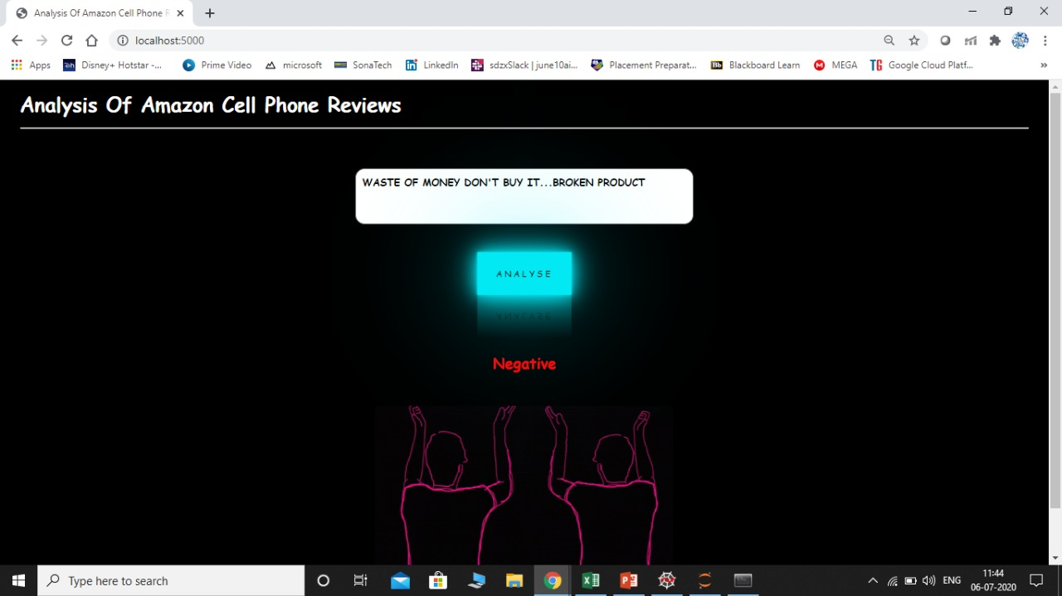

***NEGATIVE REVIEW***

***4***

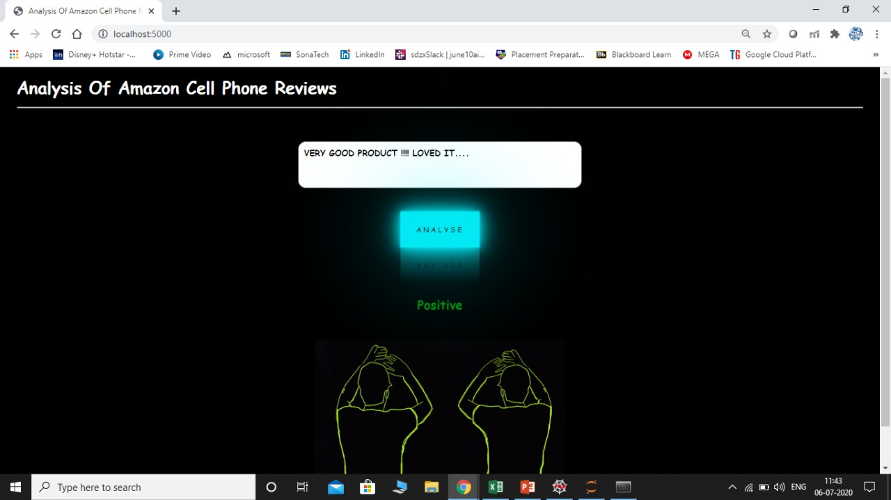

**POSITIVE REVIEW**

# *PROJECT LINK*

# *https://github.com/AnanthaPriya/Analysis-Of-Amazon-Cell-Phone-Reviews*

**5**

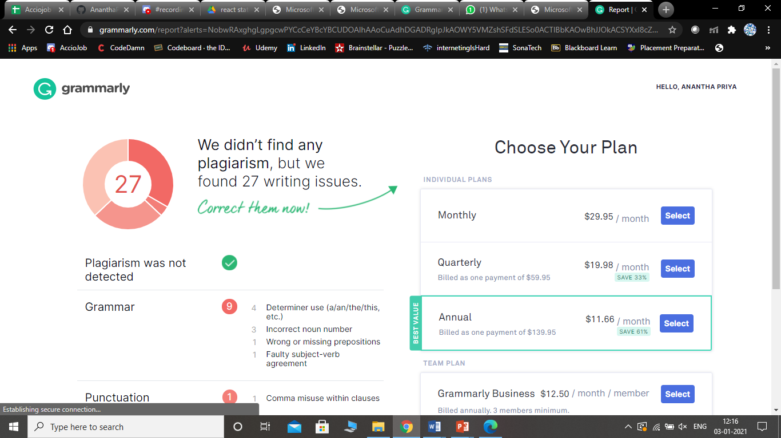

**6**